Marine Imaging Workshop 2026:  19 – 21 May 2026  Gibraltar  Contact:  SMES@unigib.edu.gi | 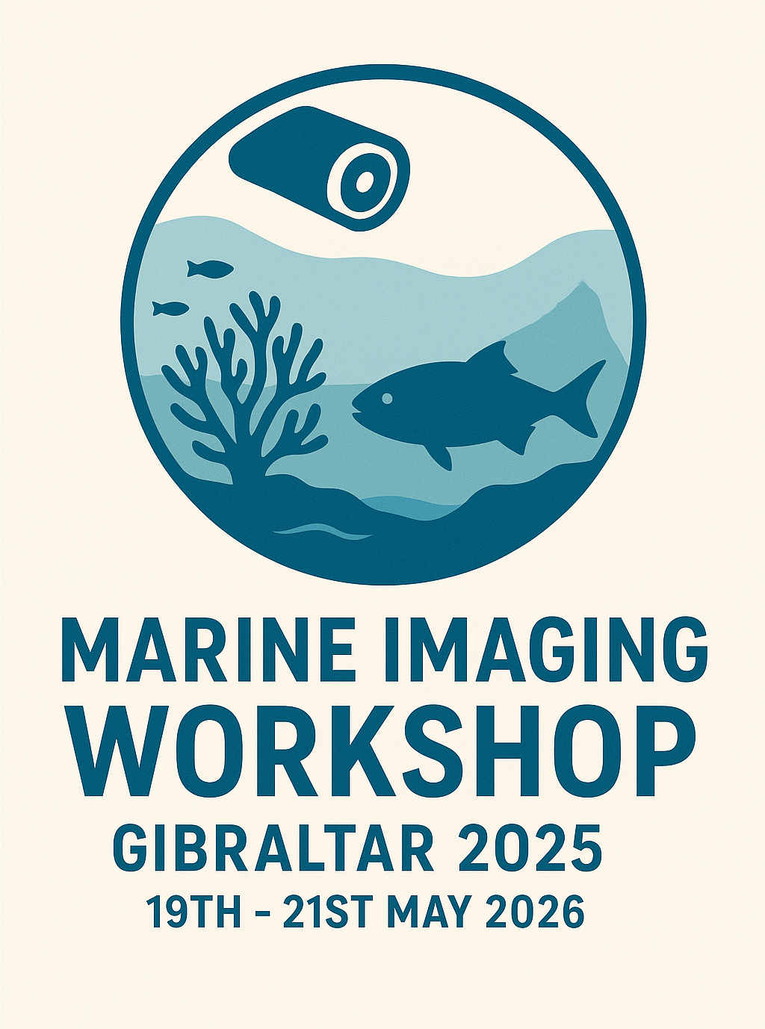

Abstract details
Author list  Please indicate presenting author in bold and use superscript numbers for affiliations | Authors:  Affiliations/Institutes:  1.  2.  3.  (add more in required)
Email address of corresponding author

Full title

Short title

Preferred presentation format | We will endeavour to allocate oral presentations as author’s primary choice; however, due to limited sessions and timeslots, poster presentations may be allocated.  ☐ Oral presentation  (12 mins + 3 mins for questions)  ☐ Interactive Workshop  ☐ Poster display & Lightning talk  (3 mins presentation time)
Abstract
Maximum 350 words

Save this file as: Abstract_Lastname_Initial
e.g. Abstract_Dissanayake_A

Please send the completed form to the MIW email:
SMES@unigib.edu.gi

subject: Abstract_ Lastname_initial_preferred format (oral, poster, workshop)
e.g.: Abstract_ Dissanayake_A_oral

